**Assignment 1 Physics Report**

Shila Das and Cody Edwards

Question:

Suppose that the Stormtroopers are 485m away. What is the correct angle for the wookiee to throw the thermal detonator so that it reaches the Stormtroopers.

Diagram:

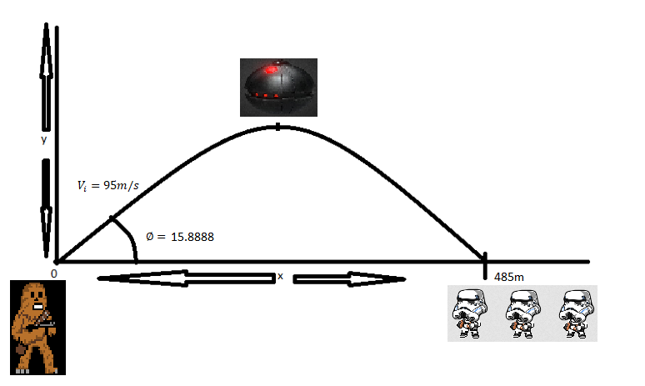Using the equation: $∅=\frac{1}{2}\sin^{-1}{(\frac{gx}{Vi^{2}})}$ which is a simplified equation to get the angle to hit the stormtroopers without factoring in the time variable, with the variables thus: g is the gravitational constant of 9.8 meters per second, x is the endpoint, or the total distance travelled of 485 meters, $Vi$ is the initial velocity of 95m/s when the thermal detonator is thrown.

Starting from the right side to get the brackets cleared, you end up with $∅=\frac{1}{2}\sin^{-1}{(0.5266)}$, which results in $\frac{31.7760}{2}$ or 15.8888 with a precision of 4 decimals